Project Management Notes

**Project**

A project is a collection of linked activities which are carried out in an organized manner by clearly defining the start point and the end point to achieve the desired results.

A project can be any undertaking that is carried out by an individual or as a group to achieve a specific aim.

**Project Management**

Project Management is a dynamic process which utilizes the resources of organization in a structured and organized manner to achieve goals identified by the organization.

It also makes use of specific knowledge, skills, tools and techniques to create value to organization.

Project Management Team is responsible for delivering project within the estimated time and allocated budget.

The primary purpose of Project Management is to predict, foresee and eliminate dangers and problems that can occur during the implementation.

**Project Management phases and cycle**

Project Initiation:

* The first stage of transforming a meaningful idea into a reality.
* Defining the project idea or concept on a broader level.
* Creating a Project Charter a document which consists of project goals, constrains, timeline and budget.
* Deciding upon the key stakeholders and decision makers in the respective domains within the project.

Project Planning:

* Lays out the roadmap of the entire project
* identifies the technical requirements for smooth functioning
* Creating a detailed project schedule to adhere to the timeline.

Project Execution:

* Project Execution phase is a phase where actual work is getting done
* Creating efficient workflows and monitoring the progress of the team.
* Maintaining coordination with several departments that are associated with the project

Project Monitoring and Controlling:

* Ensuring that there is no deviation from the initial plan on the execution
* tracks progress after each stage in a project
* Ensuring there is no error occurring in processes which are taking place
* Verifies whether tasks are carried out meeting the expectation in terms of quality.

Project Closure:

* Indicates the end of the project after the final delivery
* Completion of necessary paper works indicating the closure of project in a defined manner
* Conducting reflection meeting in order to assess the strength and weakness of the team for project for continuous improvement
* Storing the sensitive information regarding the project in a secure space for future reference.

**Benefits of Project Management:**

* Organized work plan
* increases efficiency
* improves team effectiveness
* eliminates confusion
* Align communication

**Components of Project Management:**

* Defining the reason why a project is necessary
* Specifying the quality of project deliverables
* Estimating resources and budget allocation
* Securing corporate agreement and funding
* Managing issues, risks and changes in project
* Monitoring the progress against the plan.

**Types of Methodologies in Project Management**

Waterfall model:

* Waterfall model is an approach to project management and software development which follows a linear sequence of events.
* each phase in this model is gated, teams cannot advance to one phase from another phase without completion of current phase.
* Each phase has clearly defined completion criteria and these criteria are generated in first stage of the model.
* Requirements set forth at the beginning ideally cannot be changed during the course of development project in this model.
* Waterfall Model is preferred for the projects that have well defined requirements and minimal expected changes, e.g. construction, infrastructure projects.

Agile Methodology:

* Agile is an approach to project management and specially for software development projects that prioritizes collaboration, continuous delivery and customer feedback, agile breaks work into iterative steps , which are smaller tasks are quickly completed. these iterations are done using sprints,
* Agile teams complete one sprint before moving onto the next one.
* Requirements can be changed at any time in project based on changing business needs and customer feedback.
* e.g. software development, product launches

**Sprint:**

A sprint is a pre-determined amount of time where teams determine the work to get done

**User Stories**:

* A user story is a brief and simplified explanation of a feature in a system that is currently being developed.
* The main aspect of user story is that they are conveyed from the viewpoint of user or a person who utilizes the feature.
* E.g. As a user, I want to filter search results by category so that I can find products more easily.

**Epic:**

* An Epic is a story but too big for a single sprint, it is divided into multiple stories
* E.g. improve the search experience on this platform this can be an epic.  
  User story could be implementing filters, search suggestions and a rating based sorting option.

**Issues**

* Issues are containers for fields that contain the data e.g. summary, due date, description.
* Issues are building blocks of any project
* Stories, epic and bugs are types of issues in Jira.

**Need for Project Management Tools**

* The use of project management tools ensures that project management runs smoothly.
* The tools that assist a team or an individual in doing project management tasks more effectively and efficiently
* it allows you to designate which tasks are performed in specific order and which tasks are interdependent

**Difference between Water Fall model and agile model**

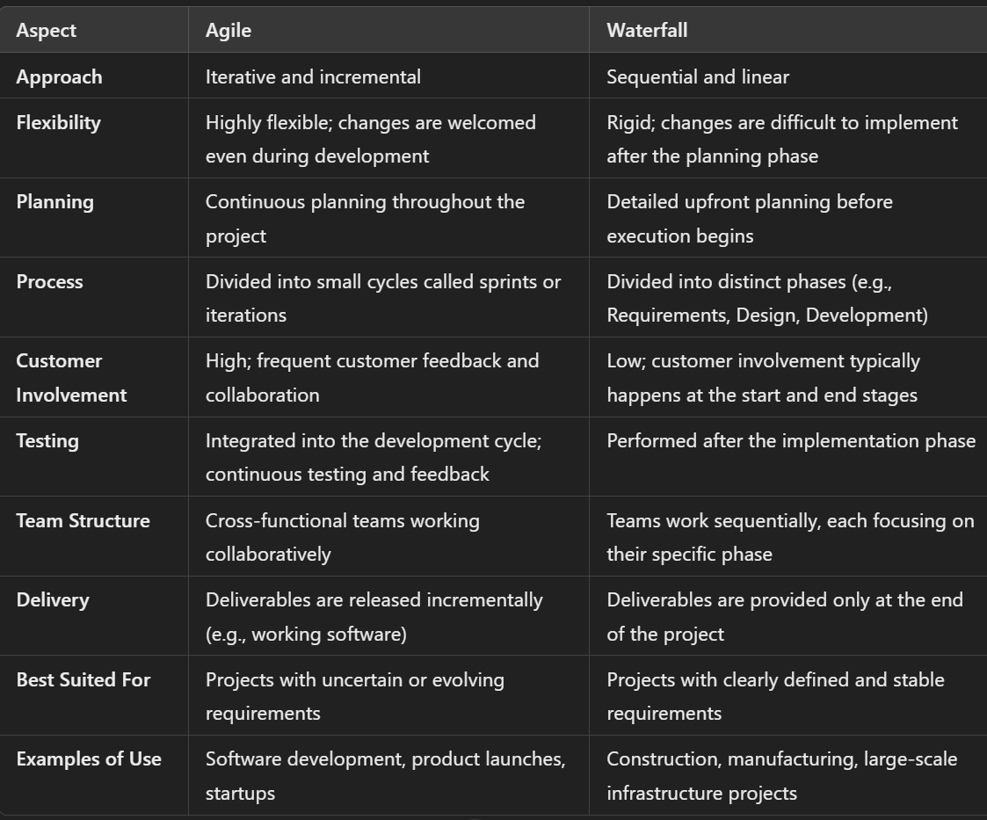

**Milestone in Project Management**

**Definition:**  
A milestone is a significant point or event in a project timeline that marks the completion of a key phase, deliverable, or decision point. It serves as a checkpoint to assess progress, ensure alignment, and facilitate stakeholder communication.

**Can AI replace everything?**

**Answer:**  
"AI can automate repetitive tasks, enhance decision-making with data-driven insights, and increase efficiency. However, it cannot replace human creativity, empathy, and strategic thinking. In project management and product development, collaboration, innovation, and understanding user needs require a human touch. AI should be seen as a tool that augments human abilities rather than replacing them entirely."

**What does success mean to you?**

**Answer:**  
"Success means consistently achieving goals while maintaining personal growth and a positive impact on those around me. Professionally, it’s about delivering valuable outcomes, fostering collaboration, and continually learning to improve. Personally, success includes balancing work with personal development and contributing to the community."